Name: ……………………………………………….. ( ) Class: ……… Date: …………………..

|  |  |  |
| --- | --- | --- |
| **1.1** | **Data Management** | **Data Tabulation, Logical Functions** |

**Data Tabulation**

When tabulating data, the rows and columns of a spreadsheet differ in how they are typically used:

|  |  |  |
| --- | --- | --- |
| **Part of Spreadsheet** | **Typical Usage** | **Description** |
| Columns | As fields | * Each column stores only one type of data. * To identify and describe the data stored in each column, column headings or field names are provided at or near the beginning of the spreadsheet. * The data type of each column is set to the most appropriate option before any data in entered. |
| Rows | As records | * Each row represents a set of related data that can be divided into fields |

A description of the most common data types are provided below:

|  |  |
| --- | --- |
| **Data Types** | **Description** |
| General | Used for data with no specific type, or when the type of data cannot be known ahead of time. However, the spreadsheet may change the data type away from General based on what is entered. Since this behaviour can be unexpected, It is advisable to avoid using General and set data type to the most appropriate option *before* any data in entered. |
| Number | Used for numbers. Number of decimal places to display and digits separator (if any) can be specified. |
| Currency | Used for money. Displays the amount with a currency symbol (default is a dollar sign $) and two decimal places. Currency symbol to display can be specified. |
| Date | Used for dates. Different date styles to display can be specified. |
| Time | Used for times and durations. Different time styles to display can be specified. |
| Percentage | Used for rates, ratios and proportions. Typically displayed and entered as a number with a “%” appended; treated as the number divided by 100 when used in calculations, e.g., 5% * 20 will calculate 0.05 * 20, which is equal to 1. |
| Text | Used for text. Displays exactly what is entered. |

1. Alan, Betty, Charlie and Daisy take part in a joint study. As part of this study, they need to keep a log of how much each participant spends each day over a period of 30 days. To do this, the participants use a spreadsheet to keep their log entries. Each log entry has:
   * The date of the log entry
   * The name of the person entering the log entry
   * The amount spent by the person on the date of the log entry

What should be the headings and data types for the spreadsheet’s three columns?

|  |  |  |  |
| --- | --- | --- | --- |
|  | **Column A** | **Column B** | **Column C** |
| **Column Heading** |  |  |  |
| **Data Type** |  |  |  |

1. A greeting card producer wishes to keep track of which greeting phrases (e.g. “Happy Holidays”) customers can request from him, the price of each greeting phrase and the applicable percentage discount of each phrase (if any). What should be the headings and data types for a spreadsheet to keep track of the required data?

|  |  |  |  |
| --- | --- | --- | --- |
|  | **Column A** | **Column B** | **Column C** |
| **Column Heading** |  |  |  |
| **Data Type** |  |  |  |

1. Suggest an appropriate data type for each column of the spreadsheet below:

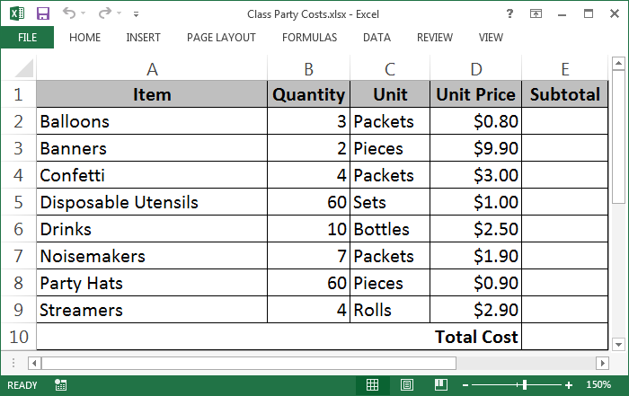

|  |  |  |  |  |  |
| --- | --- | --- | --- | --- | --- |
|  | **Column A (Item)** | **Column B (Quantity)** | **Column C (Unit)** | **Column D (Unit Price)** | **Column E (Subtotal)** |
| **Data Type** |  |  |  |  |  |

**Logical Functions**

In spreadsheets, the following relational operators result in logical values (TRUE or FALSE):

|  |  |
| --- | --- |
| **Operator** | **Meaning** |
| < | Less than |
| <= | Less than or equal to |
| > | Greater than |
| >= | Greater than or equal to |
| = | Equal to (Equivalence) |
| <> | Not equal to (Non-equivalence) |

Logical values can then be manipulated by the following logical functions:

|  |  |  |
| --- | --- | --- |
| **Function** | **Syntax** | **Description** |
| IF() | =IF(logical_test, value_if_true, value_if_false) | Returns value_if_true (i.e. the second argument) when logical_test is TRUE and value_if_false (i.e. the third argument) when logical_test is FALSE. |
| AND() | =AND(logical1, logical2, …)  Only the argument logical1 is compulsory. The arguments from logical2 onwards are optional.  logical1, logical2, etc. can be either logical values or range/cell references. | Returns TRUE when all given logical values (logical1, logical2, etc.) or values in the given range/cell references are TRUE. Otherwise, returns FALSE. |
| OR() | =OR(logical1, logical2, …)  Only the argument logical1 is compulsory. The arguments from logical2 onwards are optional.  logical1, logical2, etc. can be either logical values or range/cell references. | Returns TRUE when any of the given logical values (logical1, logical2, etc.) or values in the given range/cell references is TRUE. Otherwise, returns FALSE. |
| NOT() | =NOT(logical) | Returns TRUE when logical is FALSE and FALSE when logical is TRUE. |

1. Predict the resulting value of the following formulas:
2. =OR(AND(IF(3>2, FALSE, TRUE), IF(2>3, 2, 3)>2), FALSE)

………………………………………………………………………………………………………………………………………………

1. =OR(AND(IF(2>3, TRUE, FALSE), IF(3>2, 3, 2)>3), TRUE)

………………………………………………………………………………………………………………………………………………

1. =OR(AND(FALSE, TRUE, FALSE), 2<>3, IF(TRUE, FALSE, TRUE))

………………………………………………………………………………………………………………………………………………

1. The following spreadsheet is used to keep track of various details for some students:

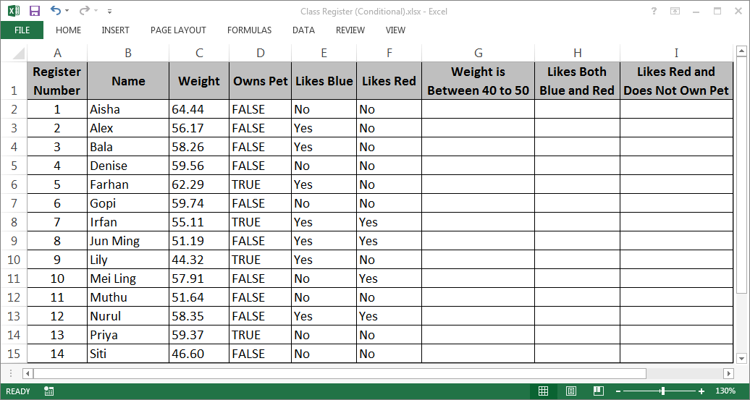

1. Suggest a formula for cell **G2** that can be copied into **G3:G15** so that column G correctly indicates whether each student has a weight between 40 and 50 (inclusive). Each cell in **G2:G15** would have to display either “Yes” or “No”.

………………………………………………………………………………………………………………………………………………

1. Suggest a formula for cell **H2** that can be copied into **H3:H15** so that column H correctly indicates whether each student likes both blue and red. Each cell in **H2:H15** would have to display either “TRUE” or “FALSE”.

………………………………………………………………………………………………………………………………………………

1. Suggest a formula for cell **I2** that can be copied into **I3:I15** so that column I correctly indicates whether each student likes red and also does not own a pet. Each cell in **H2:H15** would have to display either “Yes” or “No”.

………………………………………………………………………………………………………………………………………………